Quarterly (October to December) Report, 2018

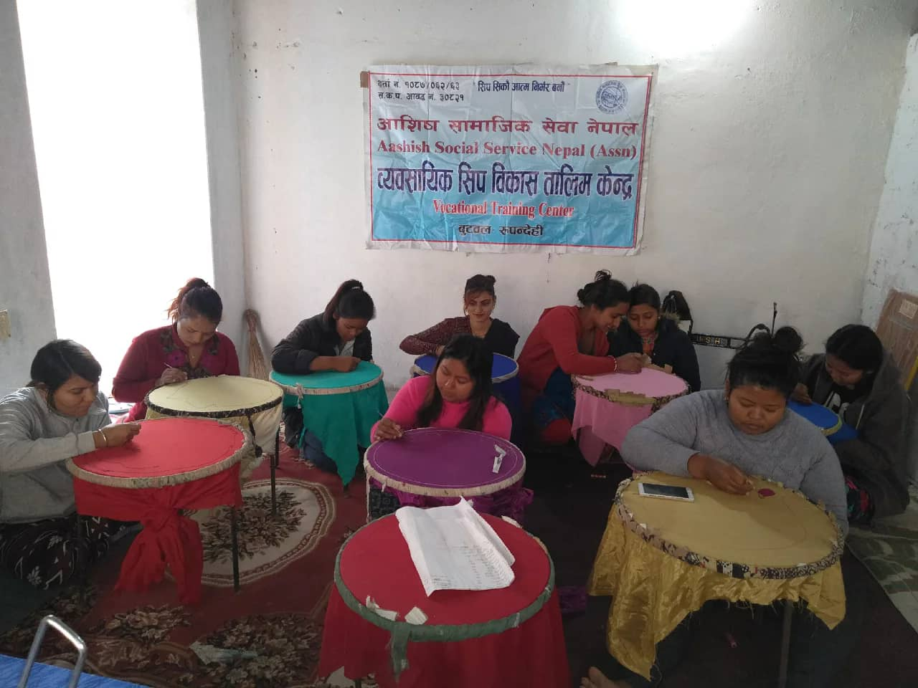

Published by
Aashis Social Service Nepal
Butwal, Rupandehi, Nepal

Email- assnepal2006@gmail.com

1. Aashis Social Service Nepal (ASSN)

1.1. Organization Profile

Name:- Aashis Social Service Nepal
Office Location:- Butwal Sub-Metropolitan City-2, Tallo Phulwari, Rupendehi District, 5 no. Provence.
Contact Person:- Bikram Bhandari
Post:- Executive Director
Contact Phone:- 009779847119830
Fax:-
E-mail:- assnepal@gmail.com/bikrambh99@yahoo.com
Registration:- At Rupandehi District
Date:- 5th September 2006
Registration No.:- 1087
PAN NO.:- 303782726
Registration at social welfare council No.:- 20821
Date:- 14th Nov.2006
Bank Account – Bank of Kathmandu LTD.Butwl branch
A/C No. 010300000534
Bank Swift Code: BOKLNPKA
Working Committee membership no.:- 7 male 4 female 3

Projects of ASSN
1. Against Girls Trafficking.
There are, however, many approaches to prevent girl trafficking. ASSN has been applying some of such approaches in the field. The programmes' activities and achievement of ASSN have been described below in the sub- topics of each events
1.1. Objective of ASSN's Prgrammes.
The main objective of the ASSN's programmes is to stop girls trafficking in Nepal and the specific objectives of the programmes are as per following.
- To run patrolling and counseling at border between India and Nepal and Butwal Bus station.
- To Support the Nepal police to identify the traffickers to punish them.
- To save women and girls from selling the brothels of different cities of Indian cities and other third countries.
- To raise awareness on women and girls trafficking in the Communities.
- To make self-dependent to backward communities' women through different Vocational, skill development and income generating programmes in the backward communities.
- To support women and girls for micro enterprises
- To provide shelter home to women and girls who have return back in Nepal after being trafficked and those women who are extremely high risk of trafficking and those who have found in the border while monitoring in the border.
- To make empower to women and girls of the communities.

1.2. Geographical Area of the Programmes
At present, ASSN has been working in Rupandehi, Kapilvastu and Nawalparasi districts of 5 no province of Nepal.

1.3. Patrolling Programme.
Patrolling programme is running continuously to prevent girls trafficking. Now ASSN has been patrolling and counseling events at Sunauli boarder, and Butwal Bus Station of Rupandehi district and Thutibari Boarder of Nawalparasi diatrict. Rupendehi district of Nepal has become a main transit point for women trafficking. Through this district and the Sunauli boarder, women and girls from different districts are taking India and other foreign countries for different purposes. Among the Nepal- India open border, Sunauli is a main point for crossing the India many people uses this boarder while going to India. So, ASSN has been mobilizing volunteers at Sunauli boarder, Butwal Bus station and Thutibari boarder which is also one of the major boarders between India and Nepal through this boarder also trafficker take Nepal girls and Girls in India. We have found many girls moving to India for works but they are actually taken by Traffickers for prostitution. We have made those girls returned to their home after counseling by boarder staffs and those whose do not have parents and are homeless and helpless are kept in grace shelter home.
1.3.1. Activities.
Following activities have been conducting in Suauli and Thutibari boarders and Butwa Bus Station under boarder patrolling and counseling programme.
- Strictly monitored in Sunauli and Thutibari boarders and Butwal Bus Station upon the women and girls who are going to India and crossing the border.
- Counseling to those women whom seem doubt
- Those girls who are going to India with unknown person in different pretend and no have their parents in home and are at high risk of trafficking is referred to grace shelter home.
1.3.2. Method/ Approach
The method / approach of boarder patrolling programme has been written below
- Monitor in border and Butwal bus station with coordination of Nepal police.
- Staff stays in boarders and Bus Station area watching the women going to India.
- Counseling to women who are going in India.
1.3.3. Achievements
The achievements of patrolling programme since October to December are below.

1.3.4. Monitoring
ASSN border patrolling programme had been monitored by the executive body of ASSN.
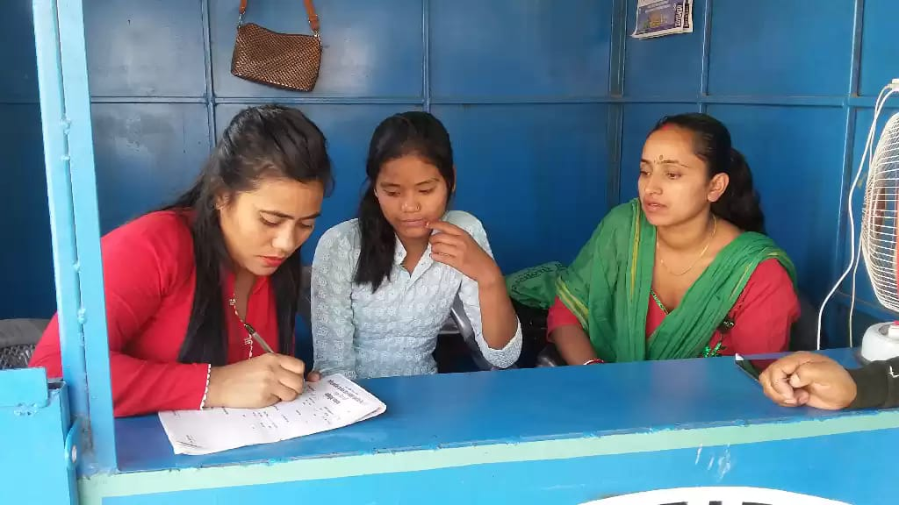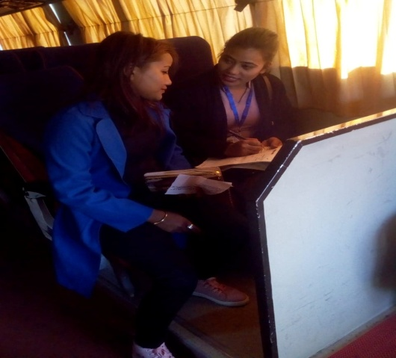
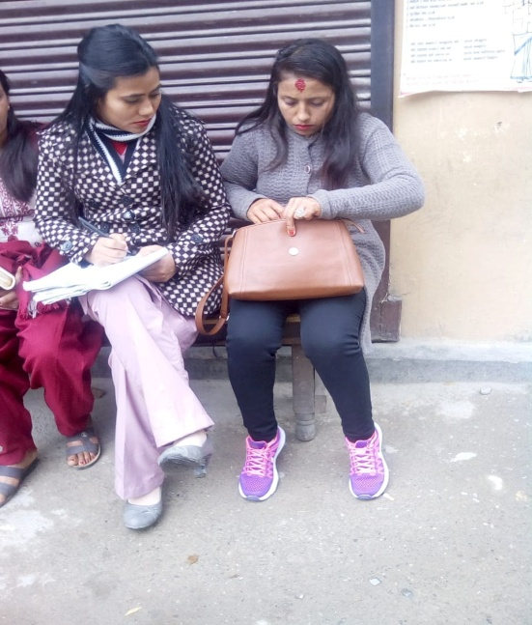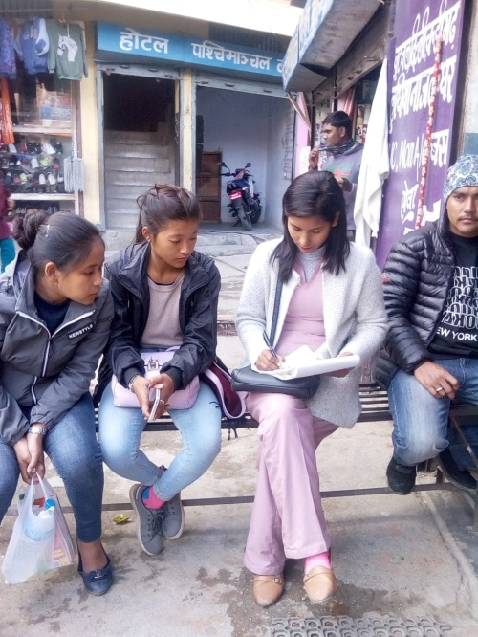
Pictures while counseling to girls by the ASSN staff and the Booth put by ASSN at Thutibari Boarder

2. Income Generating / Vocational and Skill Development Programmes
Income generating/ vocational and skill development programme helps to women and girls to become economically self-dependent generating the income themselves running small entrepreneurs. In the context of Nepal poverty is extreme even in the urban along with rural areas the government is unable to provide job to people. Due to the lack of job or income source many young girls have felt on the trap of trafficker in the hope to getting better job in India and other foreign countries. So, these activities attempt to solve this problem. There is need such types training to make women economically self depend.
2.1. Activities
The activities conducted by ASSN under the income generating/ vocational and skill development training programme are below.

i. Sewing and Cutting Training
During this quarter Sewing and cutting Training was conducted at Butwal Sub-Metropolitan City ward no-2. This Training was started on October and will be run for six months in the training 10 trainees are learning skill about clothes sewing and cutting. This training has held with the financial support of free The beloved Nepali daughter, and has organized by ASSN.
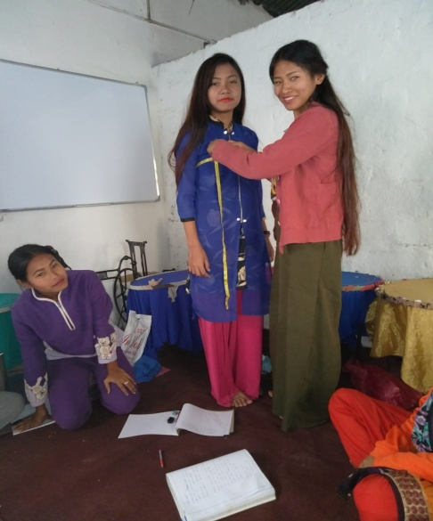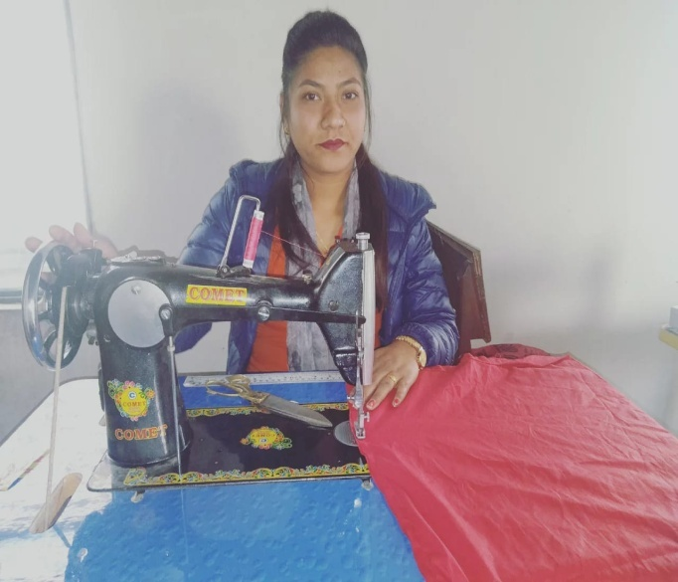

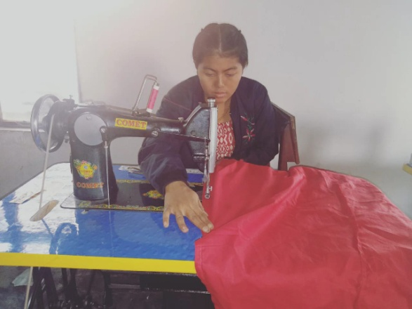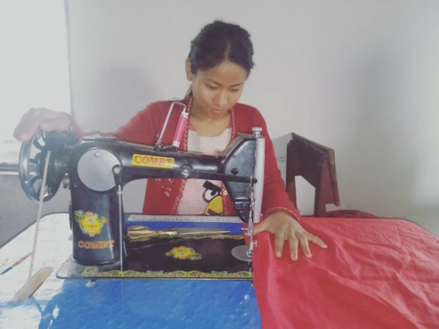
ii Embroidering Training
In this quarter one event of embroidering training has been carried out. The training has started on December and will run for three months. In this embroidering training 10 women and girls have been participating to learn skill to embroider clothes. The training has been held in financial support of Free the beloved Nepali Daughter.
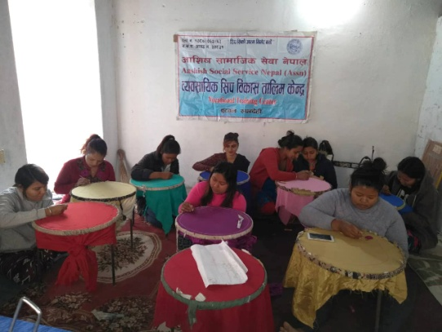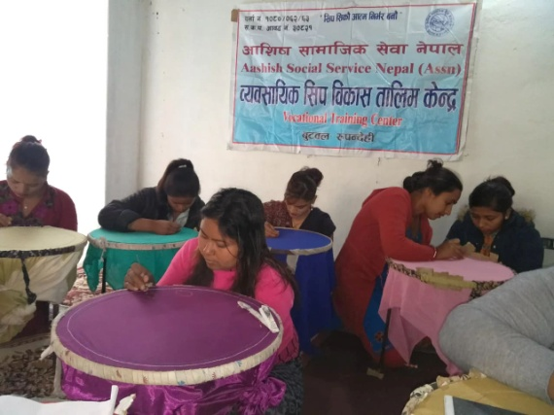

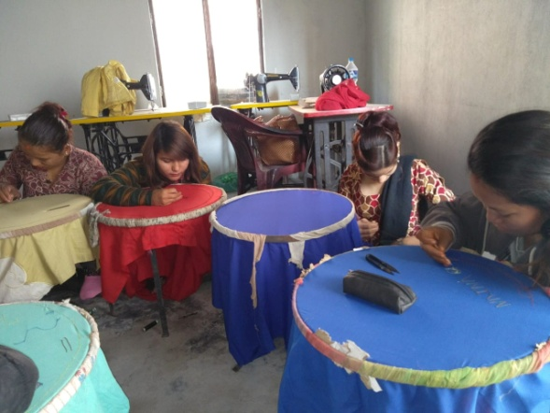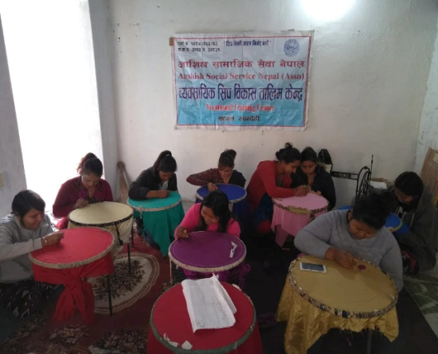

2.2. Method / Approach
The method and approach of the activities are as per following.
- Coordination with local government of Nepal.
- Participants were selected for the trainings.
- Training was provided with the base of theoretically and practically.
2.3. Achievement
The achievement of Income generating/ vocational and skill development training is below.

3. Grace Shelter Home Programme
Among all the programs of ASSN, Grace Shelter home is the most important programme. Trafficking affected girls and women are psychologically depressed, may have experienced physical torture and more specially, they can't adjust to their community immediately and the society do not accept them. So, such girls and women need a safe and loving environment for a bit long time to overcome the trauma and stigma they just experienced. So they need protection from harm by traffickers, who fear prosecution for their act. ASSN has provided grace shelter home facility to such girls and women to safe, healing environment. In this home different services have been provided them and are aware about the problem related with girls trafficking, sexually transmitted diseases and other trafficking related activities. Considering such situation of Trafficked girls who come in Nepal escaping from brothels and the owner of brothels sent them after infected from different sexual diseases and they can become helpless because they cannot go their parents home due to the such stigmas the society do not accept them ASSN has established a grace shelter home have 4 persons capacity. it is located at Butwal Sub-Metropolitan City ward No-2, Pakhapani.
3.1. Activities
The activities to be carried out in the Grace Shelter home are below:
- Provide food to the girls and women living in the shelter home.
- Provide resident to the girls and women living in the shelter home.
- Provide different types of vocational and skill development training to the girls and women to rehabilitation them in the community.
- Provide treatment facility to them.

Vocational Skill Development training
In the grace shelter home different facilities are provided out of them one is vocational and skill development training. In the grace shelter home different types of vocational and skill development trainings are provided along with residential package to girls and women of grace shelter home that can be helpful them to be rehabilitation in the community and become self-dependent generating income. Even in this quarter there are 3 sisters.
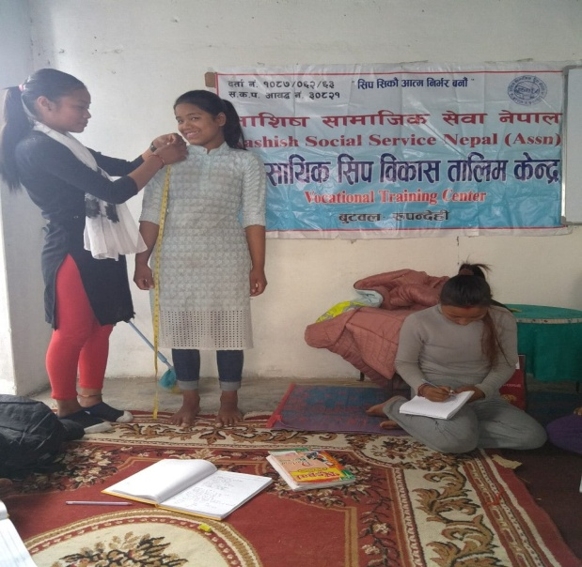

Health facility
In this period normal fever and cold flue problems had been seen to the sister and treatment was made them taking medicine from the nearest medical.
3.2. Method/ Approach
The methods of running shelter home are as follow;
- Appoint and house mother to care the girls and women.
- Take them at health center for treatment
- Trainings are provided to them theoretically and practically.
3.3. Achievement
The achievements are below;
- Currently 3 girls are living in the grace shelter home.
- Different types of trainings they have been learning living there.
- Normal diseases had been seen and did remedy taking the medicine from the nearby medical.
4. Micro Enterprises Programme
The micro- credit business programme is also the main part of ASSN. Its main purpose is to train the victimized women and make them independent by giving skill development training and loan to run their business. The loan provided to them for establish business on the basis of skill what they have learnt is without interest and they have to return the loan in the installation basis. Now, two groups were running for micro credit business, From April 2015, we have provided the loan to them retuning from pervious groups where 9 members are participated. ASSN has been providing them skill development training according to their needs and will invest in their business to make them independent.
4.1. Activities
The activities done under this programme are below;
- Provide necessary training.
- provide loan without interest to new groups to establish business
4.2. Achievement
9 women are running business with the loan support of ASSN

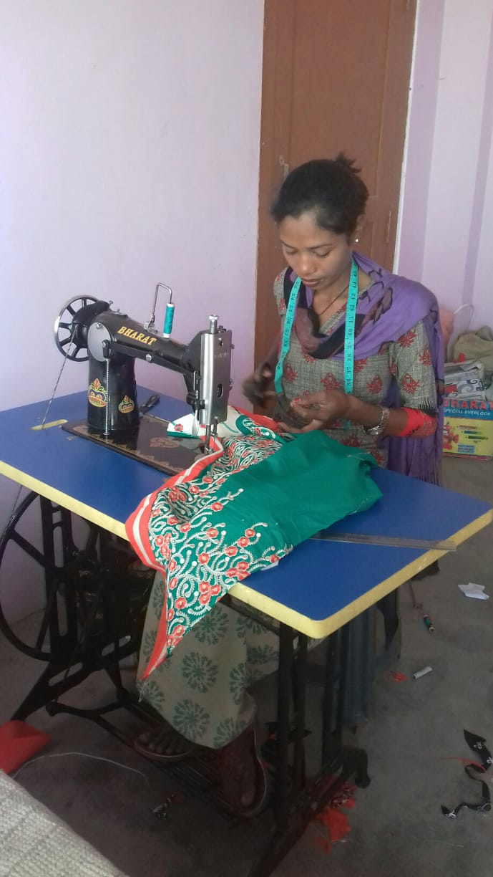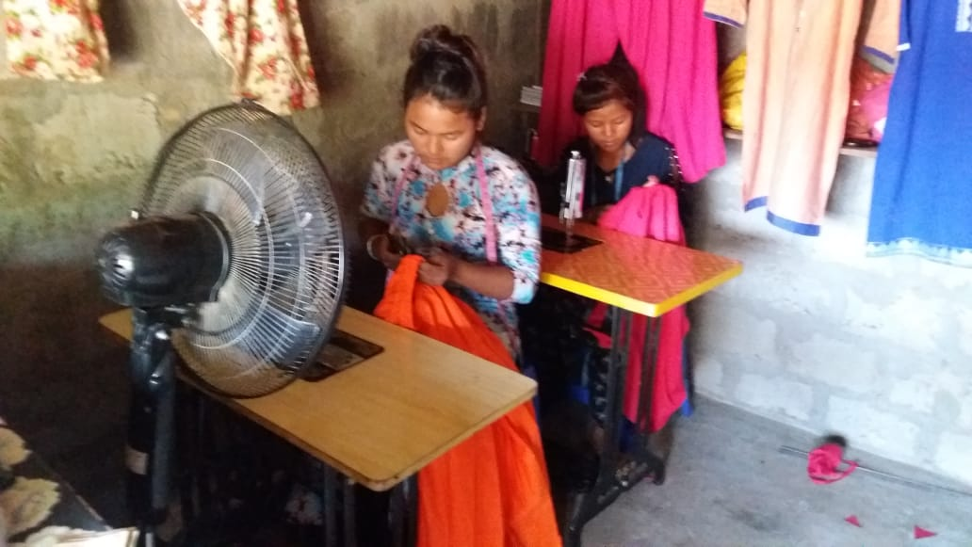

5. Education Programme
ASSN has been providing education to the homeless, poor, disable and orphan children of squatter and slum area.
5.1. Geographical Area of the programme
Butwal Sub-Metroplitan City ward no- 11 Majuwa, Rupandehi dstrict
5.2. Objective
The objectives of the programme are is to provide education to the children of orphan, homeless, poor, disable.

6.3. School Programme

Under the school programme ASSN has been providing continually Scholarship to seven pro poor children, and helpless children for their study who are studying Suryoday Primary School at Butwal Sub-metropolitan City ward no-11, Majuwa. Those seven children are getting Rs. 1,000 per children per month and it has been spending 7,000/- per month for seven children scholarships.

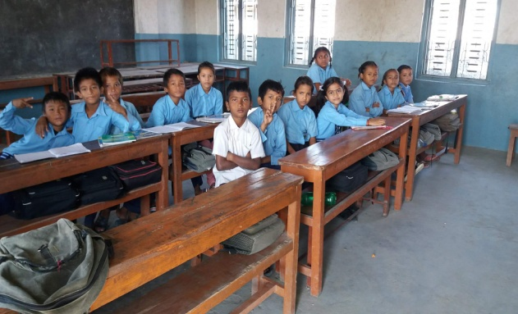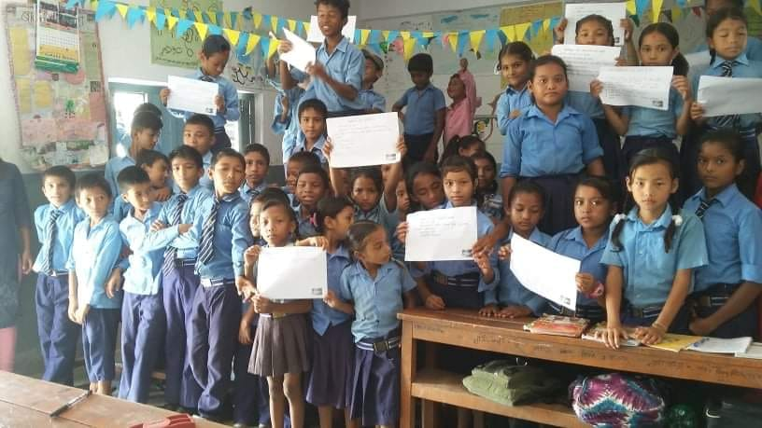

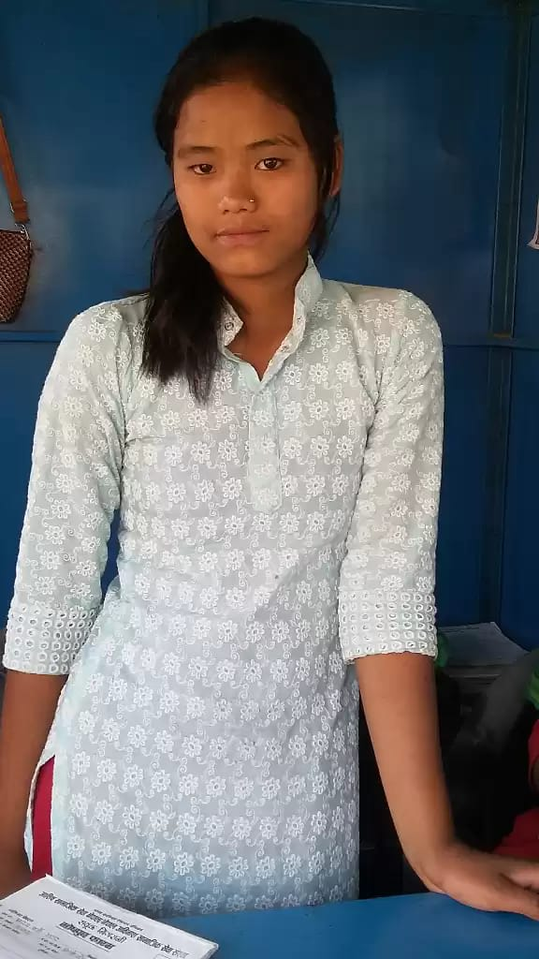
Story of Success

Case study of Jharna Gharti Magar
My name is Jharana Gharti Magar. I was 16 years old. My address is Baglung District of West Nepal. My father's name is Hum Bahadur Gharti Magar and Mother's name is Khima Kumari Gharti Magar. I was born into a middle class family of Baglung. I was first child of my parents. In my family we are 4 persons, father, mother, one brother and me. Up to grade 8 i studied in school of our village but the school was only up to grade 8 for further education we had to go in other village's school. So i went to the school of other village name Jhimekhola village. There i admitted in grade 9, while studying there i meet with a boy named Himal of the village. Then we started meet with one another, go visit different places around the village and talked on mobile phone. We began to love each other. One day the boy proposed me to get marriage and i accepted his propose because we were in love and we came in Butwal escaping from home. After coming in Butwal someday we stayed in a hotel after that we get the Bus ticket from Sita tour and travel agency to go India. Getting ticket we were sitting down on the bus. After some time we got on in the bus two sister came on the bus and asked me," where are you going to sister". I did not say anything and they also asked with Himal too. He said that we are going to India after getting marriage and those sisters took us in the Booth of Aashis Social service Nepal of Butwa Bus Station. They made me good counseling there. When they counsel both of us separately and they found that the boy had already got married, listing that i wept and could not thought that now where i would go because i had escaped with him. But those sisters gave me advice to stay in grace shelter home of ASSN and i was agree with propose of those sisters and they took me in grace shelter home. Now i am living there in the grace shelter home and have been learning skill development training. Now i am so much happy.

Thanks

