Quarterly (July to September) Report, 2018

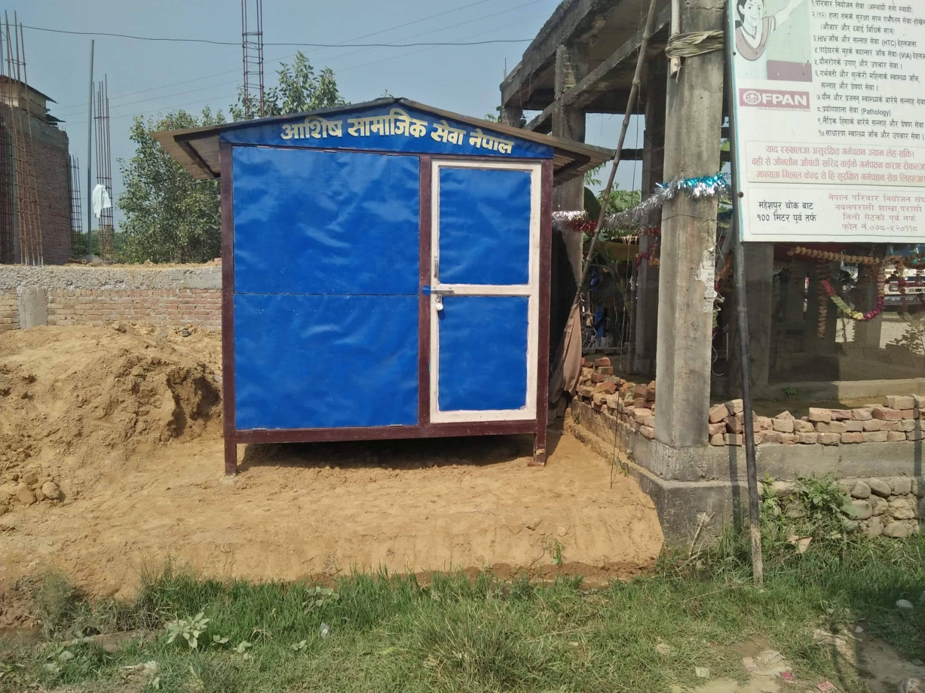

Published by
Aashis Social Service Nepal
Butwal, Rupandehi, Nepal

Email- assnepal2006@gmail.com

1. Aashis Social Service Nepal (ASSN)

1.1. Organization Profile

Name:- Aashis Social Service Nepal
Office Location:- Butwal Sub-Metropolitan City-2, Tallo Phulwari, Rupendehi District, 5 no. Provence.
Contact Person:- Bikram Bhandari
Post:- Executive Director
Contact Phone:- 009779847119830
Fax:-
E-mail:- assnepal@gmail.com/bikrambh99@yahoo.com
Registration:- At Rupandehi District
Date:- 5th September 2006
Registration No.:- 1087
PAN NO.:- 303782726
Registration at social welfare council No.:- 20821
Date:- 14th Nov.2006
Bank Account – Bank of Kathmandu LTD.Butwl branch
A/C No. 010300000534
Bank Swift Code: BOKLNPKA
Working Committee membership no.:- 7 male 4 female 3

Projects of ASSN
1. Against Girls Trafficking.
There are, however, many approaches to prevent girl trafficking. ASSN has been applying some of such approaches in the field. The programmes' activities and achievement of ASSN have been described below in the sub- topics of each events
1.1. Objective of ASSN's Prgrammes.
The main objective of the ASSN's programmes is to stop girls trafficking in Nepal and the specific objectives of the programmes are as per following.
- To run patrolling and counseling at border between India and Nepal and Butwal Bus station.
- To Support the Nepal police to identify the traffickers to punish them.
- To save women and girls from selling the brothels of different cities of Indian cities and other third countries.
- To raise awareness on women and girls trafficking in the Communities.
- To make self-dependent to backward communities' women through different Vocational, skill development and income generating programmes in the backward communities.
- To support women and girls for micro enterprises
- To provide shelter home to women and girls who have return back in Nepal after being trafficked and those women who are extremely high risk of trafficking and those who have found in the border while monitoring in the border.
- To make empower to women and girls of the communities.

1.2. Geographical Area of the Programmes
At present, ASSN has been working in Rupandehi, Kapilvastu and Nawalparasi districts of 5 no province of Nepal.

1.3. Patrolling Programme.
Patrolling programme is running continuously to prevent girls trafficking. Now ASSN has been patrolling and counseling events at Sunauli boarder, and Butwal Bus Station of Rupandehi district and Thutibari Boarder of Nawalparasi diatrict. Rupendehi district of Nepal has become a main transit point for women trafficking. Through this district and the Sunauli boarder, women and girls from different districts are taking India and other foreign countries for different purposes. Among the Nepal- India open border, Sunauli is a main point for crossing the India many people uses this boarder while going to India. So, ASSN has been mobilizing volunteers at Sunauli boarder, Butwal Bus station and Thutibari boarder which is also one of the major boarders between India and Nepal through this boarder also trafficker take Nepal girls and Girls in India. We have found many girls moving to India for works but they are actually taken by Traffickers for prostitution. We have made those girls returned to their home after counseling by boarder staffs and those whose do not have parents and are homeless and helpless are kept in grace shelter home.
1.3.1. Activities.
Following activities have been conducting in Suauli and Thutibari boarders and Butwa Bus Station under boarder patrolling and counseling programme.
- Strictly monitored in Sunauli and Thutibari boarders and Butwal Bus Station upon the women and girls who are going to India and crossing the border.
- Counseling to those women whom seem doubt
- Those girls who are going to India with unknown person in different pretend and no have their parents in home and are at high risk of trafficking is referred to grace shelter home.
1.3.2. Method/ Approach
The method / approach of boarder patrolling programme has been written below
- Monitor in border and Butwal bus station with coordination of Nepal police.
- Staff stays in boarders and Bus Station area watching the women going to India.
- Counseling to women who are going in India.
1.3.3. Achievements
The achievements of patrolling programme since July to September are below.

1.3.4. Monitoring
ASSN border patrolling programme had been monitored by the executive body of ASSN.
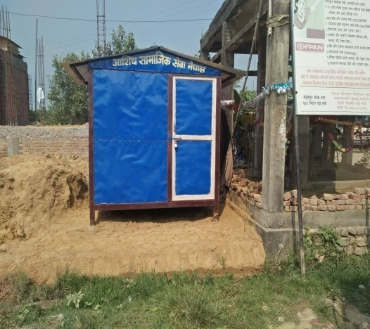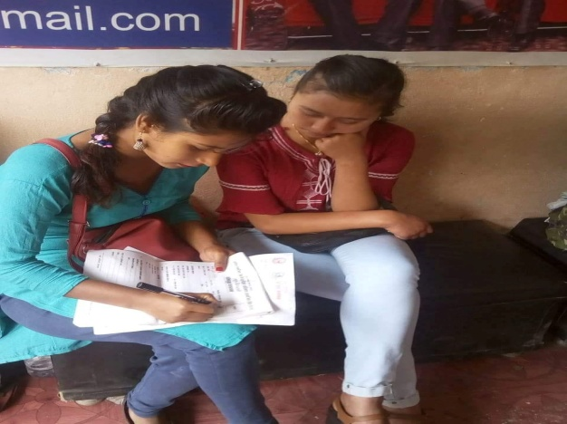

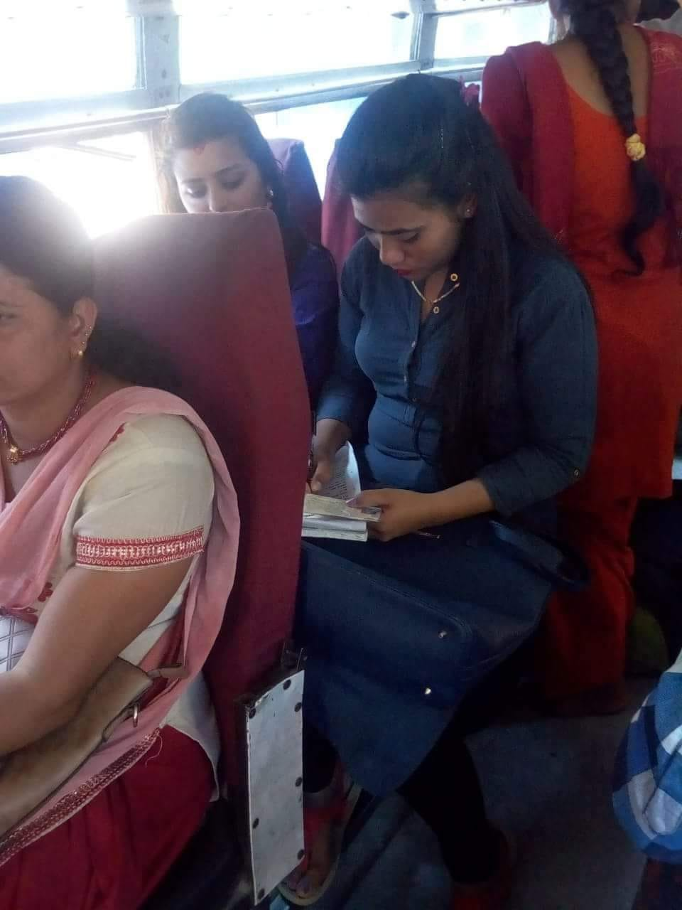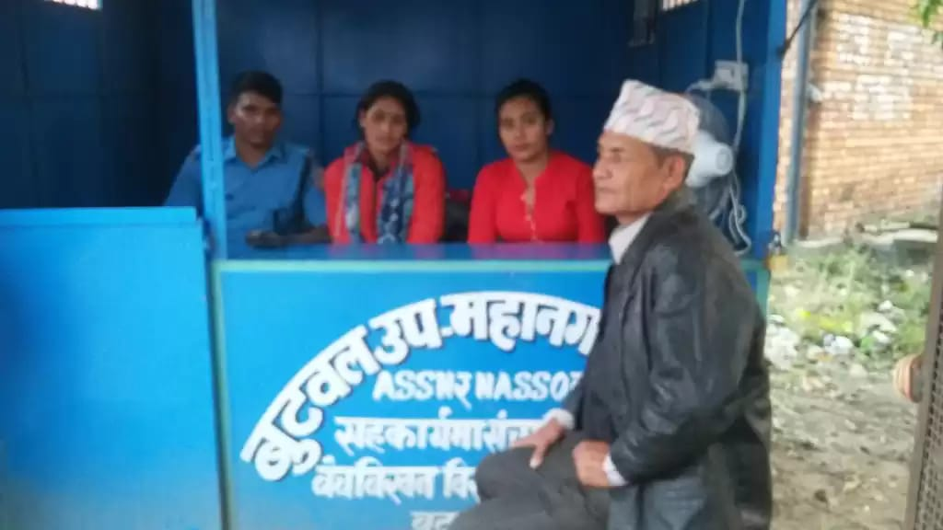

Pictures while counseling to girls by the ASSN staff and the Booth put by ASSN at Thutibari Boarder

2. Awareness Raising and Empowerment Programme
Awareness raising and empowerment was conducted in the backward community where women and girls are high risk of trafficking and domestic violence and because of the lack of awareness. Due to the lack of awareness and illiteracy many women and girls, have easily felt on trap of trafficker. So it is necessary to conduct such programmes. After raising awareness women and girls from that they can save themselves from the traffickers.
2.1. Activities
Under this programme following activity was conducted in the community the detail is below.
- awareness raising orientation about the women trafficking and domestic violence

One day awareness raising orientation about the women trafficking and domestic violence had been held in Bangesal of Pyuthan District. In this orientation 26 women and girls were participated and in the orientation Youb raj B.K. had facilitated about the women trafficking and domestic women violence. He also imparted them about the legal remedies of the domestic violence against women and trafficking.
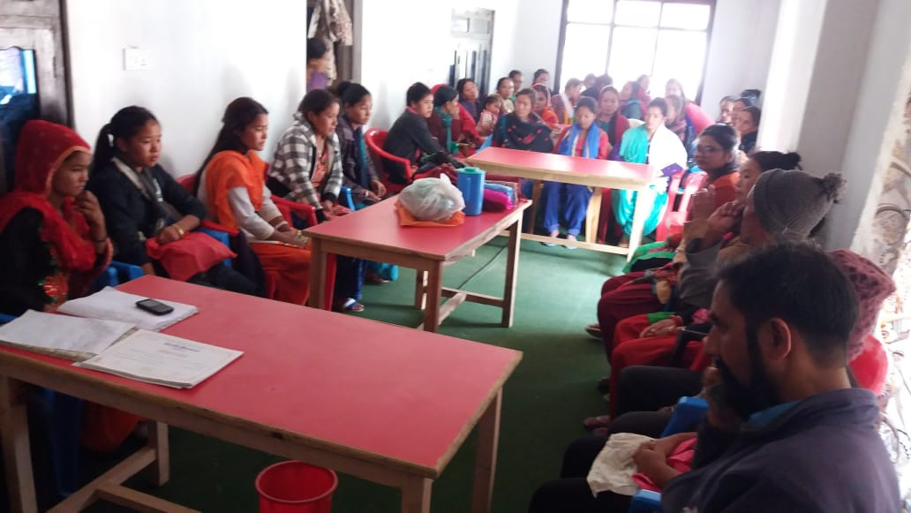
2.2. Method / Approach
The method / approach of conducting awareness rising and street drama programme are as follow.
- Coordination with local governance.
- Coordination with local community.
- Coordination with local women and girls.
- Facilitation by the ASSN Staffs.
2.3. Achievements
The achievements of the activity of orientation programme are below.
i. 26 women have benefitted from the awareness raising orientation they had gain knowledge about the legal remedies process of domestic violence and women trafficking against women

3. Income Generating / Vocational and Skill Development Programmes
Income generating/ vocational and skill development programme helps to women and girls to become economically self-dependent generating the income themselves running small entrepreneurs. In the context of Nepal poverty is extreme even in the urban along with rural areas the government is unable to provide job to people. Due to the lack of job or income source many young girls have felt on the trap of trafficker in the hope to getting better job in India and other foreign countries. So, these activities attempt to solve this problem. There is need such types training to make women economically self depend.
3.1. Activities
The activities conducted by ASSN under the income generating/ vocational and skill development training programme are below.

i. Sewing and Cutting Training
During this quarter Sewing and cutting Training was conducted at Omsatiya rural municipality ward no- 4 and Khalanga Municipality ward no- 3 Bijuwar, Pyuthan District. These Training were started on July and closed on at the last of September during these three months 32 trainees were learnt skill about clothes sewing and cutting. These two events trainings had held with the financial support of Omsatiya rural municipality, Rupandehi and Khalanga Municipality and ASSN. 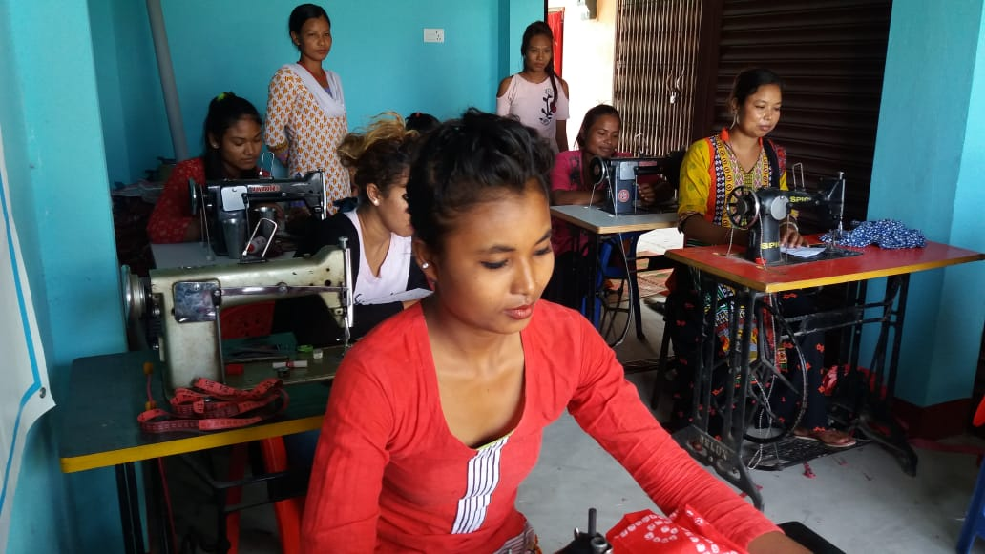 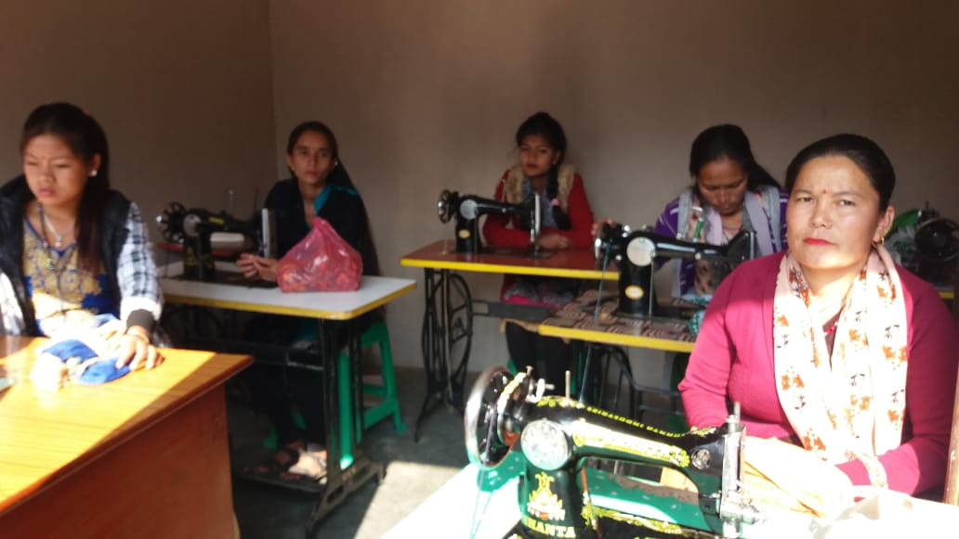

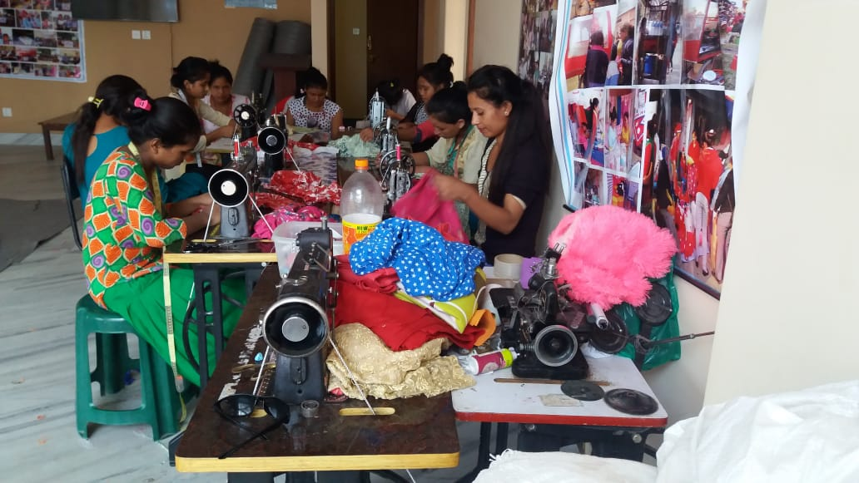
3.2. Method / Approach
The method and approach of the activities are as per following.
- Coordination with local organization and Government line agencies.
- Participants were selected for the trainings.
- Training was provided with the base of theoretically and practically.
3.3. Achievement
The achievement of Income generating/ vocational and skill development training is below.
- 32 women and girls have been benefitted from the sewing and cutting training
4. Grace Shelter Home Programme
Among all the programs of ASSN, Grace Shelter home is the most important programme. Trafficking affected girls and women are psychologically depressed, may have experienced physical torture and more specially, they can't adjust to their community immediately and the society do not accept them. So, such girls and women need a safe and loving environment for a bit long time to overcome the trauma and stigma they just experienced. So they need protection from harm by traffickers, who fear prosecution for their act. ASSN has provided grace shelter home facility to such girls and women to safe, healing environment. In this home different services have been provided them and are aware about the problem related with girls trafficking, sexually transmitted diseases and other trafficking related activities. Considering such situation of Trafficked girls who come in Nepal escaping from brothels and the owner of brothels sent them after infected from different sexual diseases and they can become helpless because they cannot go their parents home due to the such stigmas the society do not accept them ASSN has established a grace shelter home have 4 persons capacity. it is located at Butwal Sub-Metropolitan City ward No-2, Pakhapani.
4.1. Activities
The activities to be carried out in the Grace Shelter home are below:
- Provide food to the girls and women living in the shelter home.
- Provide resident to the girls and women living in the shelter home.
- Provide different types of vocational and skill development training to the girls and women to rehabilitation them in the community.
- Provide treatment facility to them.

Vocational Skill Development training
In the grace shelter home different facilities are provided out of them one is vocational and skill development training. In the grace shelter home different types of vocational and skill development trainings are provided along with residential package to girls and women of grace shelter home that can be helpful them to be rehabilitation in the community and become self-dependent generating income. Even in this quarter there are 2 sisters.

Health facility
In this period normal fever and headache problems had been seen to the sister and treatment was made them taking medicine from the nearest medical.
4.2. Method/ Approach
The methods of running shelter home are as follow;
- Appoint and house mother to care the girls and women.
- Take them at health center for treatment
- Trainings are provided to them theoretically and practically.
4.3. Achievement
The achievements are below;
- Currently 2 girls are living in the grace shelter home.
- Different types of trainings they are learning living there.
- Normal diseases had been seen and did remedy taking the medicine from the nearby medical.
5. Micro Enterprises Programme
The micro- credit business programme is also the main part of ASSN. Its main purpose is to train the victimized women and make them independent by giving skill development training and loan to run their business. The loan provided to them for establish business on the basis of skill what they have learnt is without interest and they have to return the loan in the installation basis. Now, two groups were running for micro credit business, From April 2015, we have provided the loan to them retuning from pervious groups where 9 members are participated. ASSN has been providing them skill development training according to their needs and will invest in their business to make them independent.
5.1. Activities
The activities done under this programme are below;
- Provide necessary training.
- provide loan without interest to new groups to establish business
5.2. Achievement
9 women are running business with the loan support of ASSN

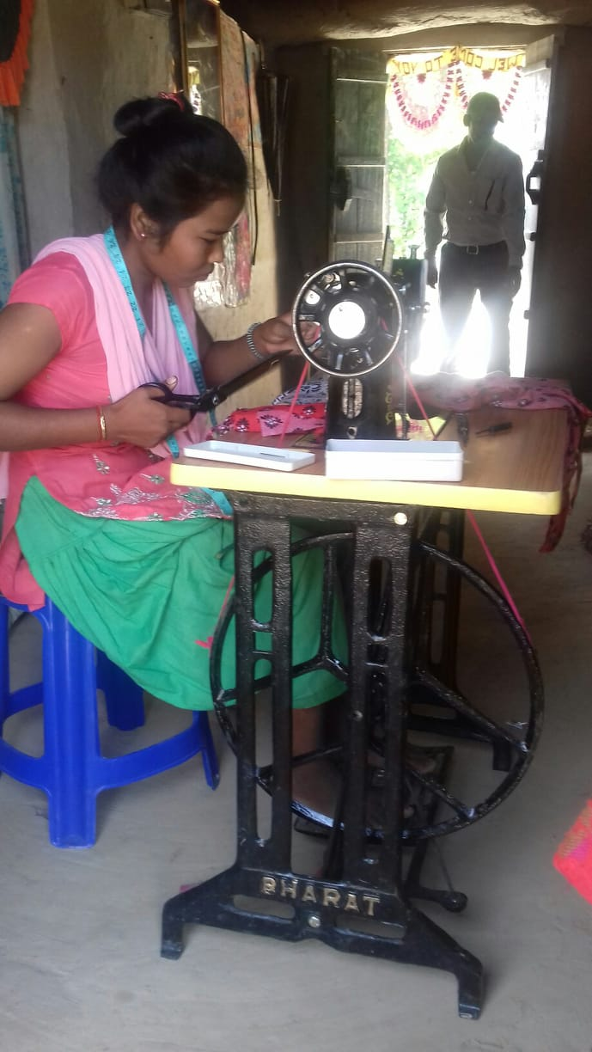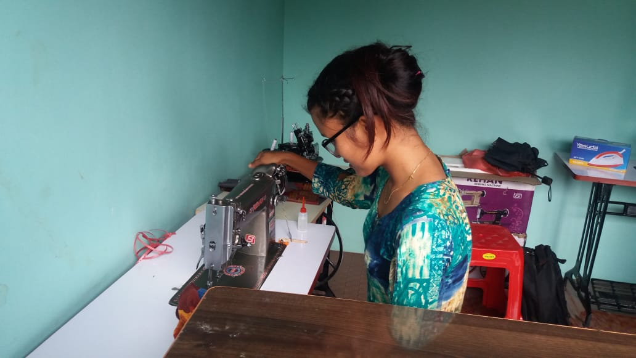
6. Education Programme
ASSN has been providing education to the homeless, poor, disable and orphan children of squatter and slum area.
6.1. Geographical Area of the programme
Butwal Sub-Metroplitan City ward no- 11 Majuwa, Rupandehi dstrict
6.2. Objective
The objectives of the programme are is to provide education to the children of orphan, homeless, poor, disable.

6.3. School Programme

Under the school programme ASSN has been providing Scholarship to seven pro poor children, and helpless children to continue their study continually who are studying Suryoday Primary School at Butwal Sub-metropolitan City ward no-11, Majuwa. Those seven children are getting Rs. 1,000 per children per month and it has been spending 7,000/- per month for seven childre scholarships.

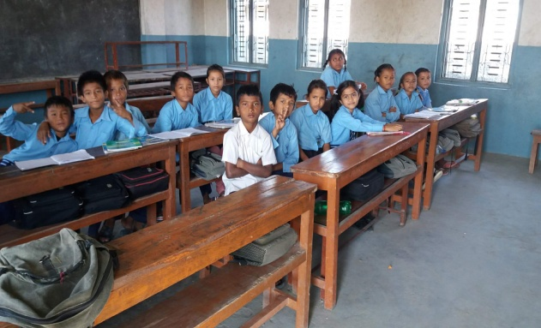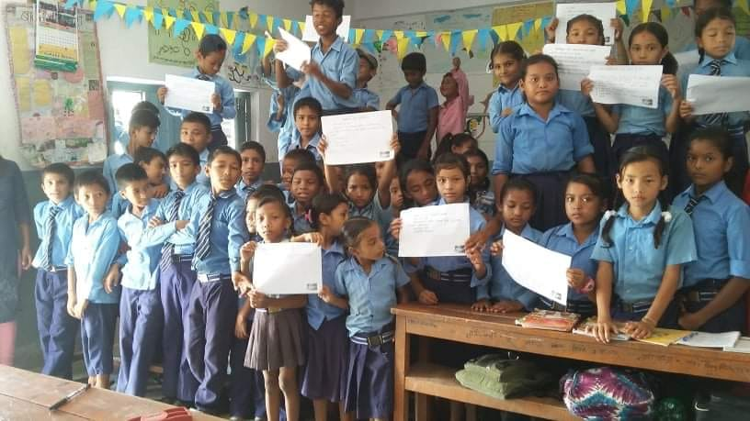

Story of Success
Case study of Arati K.C.

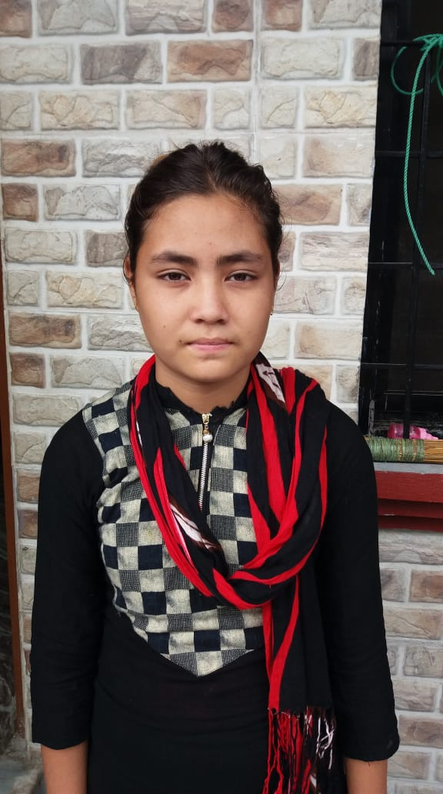
My name is Arati K. C. I am 19 years old. My permanent address is Bhimgithe VDC, Baglung District. My father name is Dhane K.C. and mother's name is Dhanmaya K.C.
I was born into medium class family. I am elder daughter of my parent in my family we are 5 persons I, my father, mother and two brothers. When i was 12 years old my mother got second marriage with other man leaving my father me and my brothers and after 5 months of left my mother. My father also got second marriage with other women. She to whom my father had gotten married has already three children two daughters and one son. So she hated me, She would make me a lot of works she would not give me to eat meal too in time. When i would go to eat meal after being tried doing lot of works there would not have meal in the pot. I was so much worried from such behaviour of my stepmother's. After that i wanted to go far more far from the house. One day i stolen the 2 thousand rupees from my father's pocket, after a week stolen the money. I decided to go to India. The next day i went to Butwal after completing all works. After reaching in Butwal I got Bus ticket for the India, I was thinking that on the Bus what would i do after approaching in India. Meanwhile, two sisters came there on the Bus in which i was sitting. They asked me my name, they also continually asked me with who are you going to India and for what are you going India? and they took me in their counseling center of Butwal Bus Station and those sister sweetly asked me about all the process to go India and i said them everything about my condition and they asked me if you are interested to stay and learn skill we sent you at our organization's Grace shelter home and i was agree with their propose and now i am living at grace shelter home of ASSN their i have been learning skill development sewing and cutting training.

Case Study of Manu Chaudhary
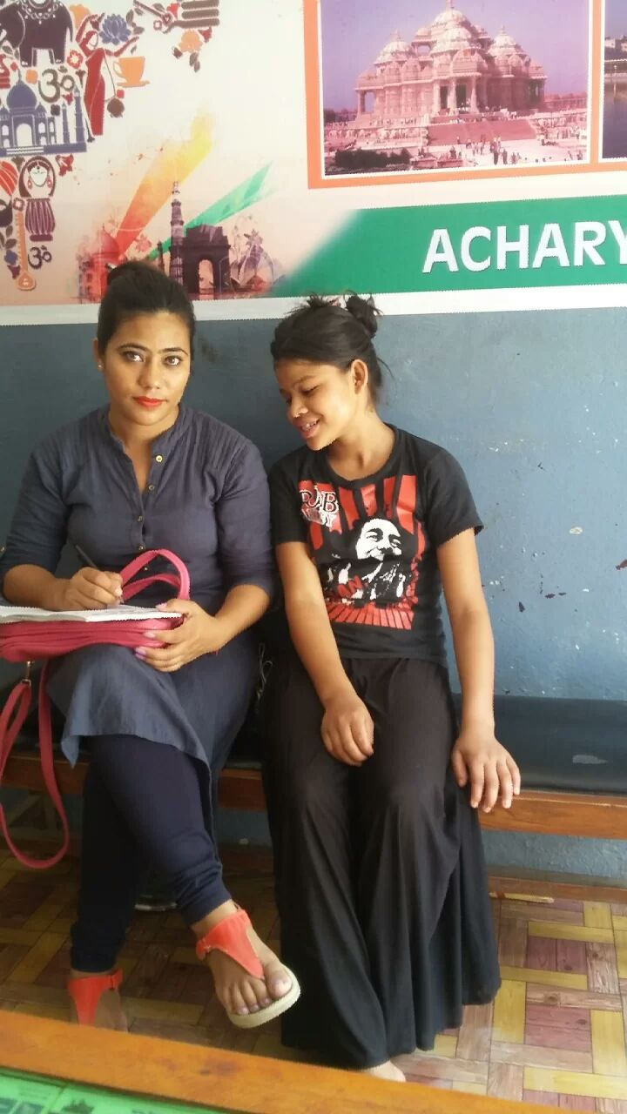
My name is Manu Chaudhary. I am 20 years old. My permanent address is Siddhartha Municipality, Rupandehi district. My father's name is Kabindra Chaudhary and mother's name is Dhana Laxmi Chaudhary. I was born into the lower class family. I was third daughter of my parent. In our family we are 8 members 4 sisters with me and we have a brother and my father and mother. Due to the lack of economy i did not get to study, Due to the interest of son of my parent we 4 sisters were born and in the last out brother was born and then our parent started hate us 4 sisters. Our father would not give us. So i started to do wage laborious work. When working in the working place a bother who also would work there with us siad me that let's go in India then to do such miserable work here in India i will make you job in a company. I thought very much and the things of the brother was good and i went to India with he and we came in Butwal Bus Station and there I stayed one day and the next day i went to get bus ticket for India and I got ticket from Supa deurali Tours and travels and i was sitting there waiting the Bus of India and after sometimes, two sisters came there. They asked me where are you going sister and i replied, " I am going to India,". Then they also asked me that why, for what and with who are you going to India? and I replied, " I am going to India with a brother who also would work with us and they gave me more advice you should not g in India with such unknown person and they took me in their counseling center of Butwal Bus station and asked me my parents phone number and they called me my father at their centre. When my father came there they gave advice about the condition and legal punishment of women violence and then they handover me to my father.
Thanks

